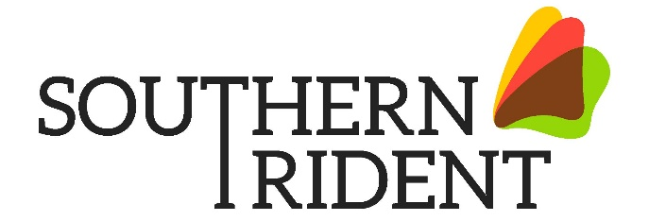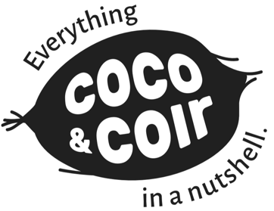
Green Today. Greener tomorrow

SOUTHERN TRIDENT PRESS RELEASE: 17th May 2021
Southern Trident announces charity partnership with Child Rights and You (CRY UK)

Following its continued market success, Southern Trident has joined hands with Child Rights and You (CRY), India’s most trusted NGO which works directly with and for underprivileged children in India at grassroots level to bring about lasting change.

CRY is on a mission to ensure children supported by its projects have access to free and quality education, proper healthcare and nutrition, and are protected from violence, abuse and exploitation including child labor, child marriage, and child trafficking. It also aims to reduce the incidence of child malnutrition and make sure children’s voices are recognized in issues that affect them. In its 42 years of relentless commitment, CRY has impacted over 3 million children across more than 700 effective grassroots partnerships.

Speaking about this corporate partnership, Balaji Manoharan, Founding Director at Southern Trident said: “There are a lot of similarities between tending to a plant and a child. Both need genuine care and come with a lot of responsibility. This is the underlying synergy between us and CRY UK as an organization. We wanted to share all the warmth we continue to receive from our customers here in the UK. The communities CRY works with are very deserving recipients of this love and care. The partnership has been thoughtfully designed in such a way that the consumer is directly a part of this giving. We hope to recreate the success and positive impact we have had with our peat free products in this partnership with CRY UK.”

Steve Harper, Southern Trident’s CEO further added “As a business that has developed from its links with India we wanted to give back and do our part to support those in need where we can. The business is incredibly proud of the fact that as we continue to grow, with every sale of our Coco & Coir products we might also help a child to prosper and have a brighter future.”

Southern Trident will be making a direct contribution to CRY for the sale of each Coco & Coir box. Consumers can find more information about Southern Trident’s link with CRY on the back of packs of our retail Coco & Coir growing media range in almost 200 garden centres across the UK.

“At CRY, we reach the most vulnerable children, and help them along a path that leads to a better tomorrow. We are truly grateful to Southern Trident for joining CRY and the children it serves on this crucial journey”, Ram Saradchandra Kumar, Chairperson CRYUK Board of Trustees added.

Southern Trident is a UK company with strong roots in India which offers high quality coir based growing medium direct from source to market in a fully Southern Trident managed seamless operation, through its brand Coco & Coir. Sustainability is at the heart of its foundation and at the core of its philosophy lies the unshakeable belief that the coconut is the perfect crop that will work for the consumer, the environment and meet the aims of the strongly held company values – green today, greener tomorrow.

For more information on Child Rights and You (CRY UK) please follow this link: http://uk.cry.org/

To book an appointment with your local sales representative please click: https://southerntrident.com/sales-agents/

For more details on our range of products visit: www.southerntrident.com/product-range
Click through to our short video to see our range: https://youtu.be/W_pGSgrrVv4
https://www.facebook.com/cocoandcoir
https://www.instagram.com/cocoandcoir/
https://www.twitter.com/cocoandcoir
https://www.linkedin.com/company/southerntrident

